



UNIVERSITY OF KWAZULU-NATAL UKZN FOOD SECURITY TASK TEAM
CHARTER



Purpose Statement and Objectives

The University of KwaZulu-Natal Food Security Task Team (“the Task Team) is established to facilitate the efficient operation of the University programme to provide food security for needy students. The aim is to have a coordinated strategy addressing the food security challenges of our students across all campuses.

Modus Operandi

The modus operandi of the Task Team will be based on teamwork and collaboration between all the representatives. Consultations with strategic role players within and outside the university will allow for a food security strategic plan and produce a model that will be revised annually.

Membership and Representation

  - The DVC and Head of College (Agriculture, Engineering & Science), in his capacity as member of the Executive Management Committee (EMC) of UKZN shall provide leadership. A full-time employee of UKZN, located in a relevant Division to deal with student matters, shall play the role of directing the Task Team operations. Senior employees, representative of all the four Colleges of UKZN, the Division for Student Administration Services, the UKZN Foundation, and the SRC shall constitute the Task Team.

  - The other stakeholders who may be members of the Task Team include, but are not limited to the following ones:

    - University Campus groups
    - University College groups
    - University student associations
    - External partners and/or funders

    - Individual members of University staff

  - Structure of the Task Team

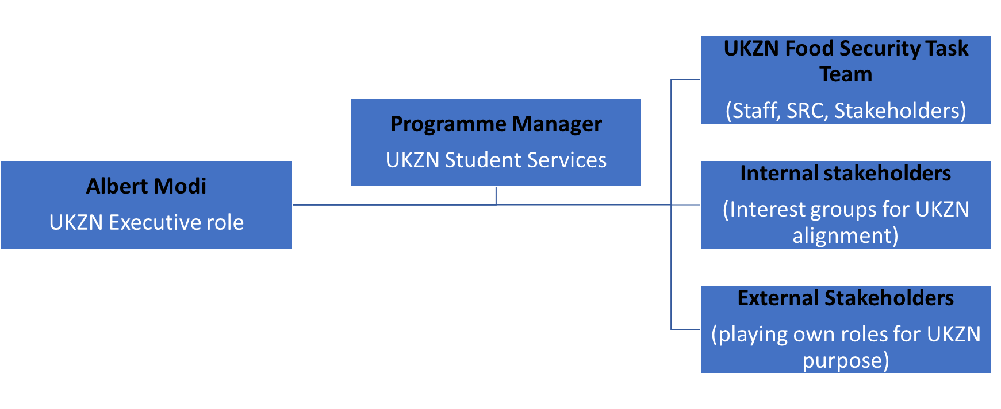

Meetings of the Task Team

  - Meetings shall be convened quarterly by the EMC representative, with adequate notice being
given (preferably one week’s notice, but shorter notice will be permitted in cases of emergency).

  - Members of the Task Team may request the convening of a meeting by means of a formal motivation to the EMC representative, the chairperson.

  - An agenda will be circulated prior to each meeting and formal minutes will be taken.

  - If the member is unable to attend a meeting, he/she will submit an apology.

  - Meetings will be chaired by the EMC representative, or his/her nominee.

Decision-making procedure at Task Team meetings

Decisions of the Task Team will be by consensus.

Amendments to Charter

The contents of the Charter will be reviewed and amended as necessary.

